CLOUD COMPUTING

ASSIGNMENT 2 – JENKINS

|  |  |
| --- | --- |
| NAME: SYED AZFAR RAYAN | CLASS: 6 – “H” |
| SRN: PES1UG20CS453 | DATE: 14/02/2023 |

1)

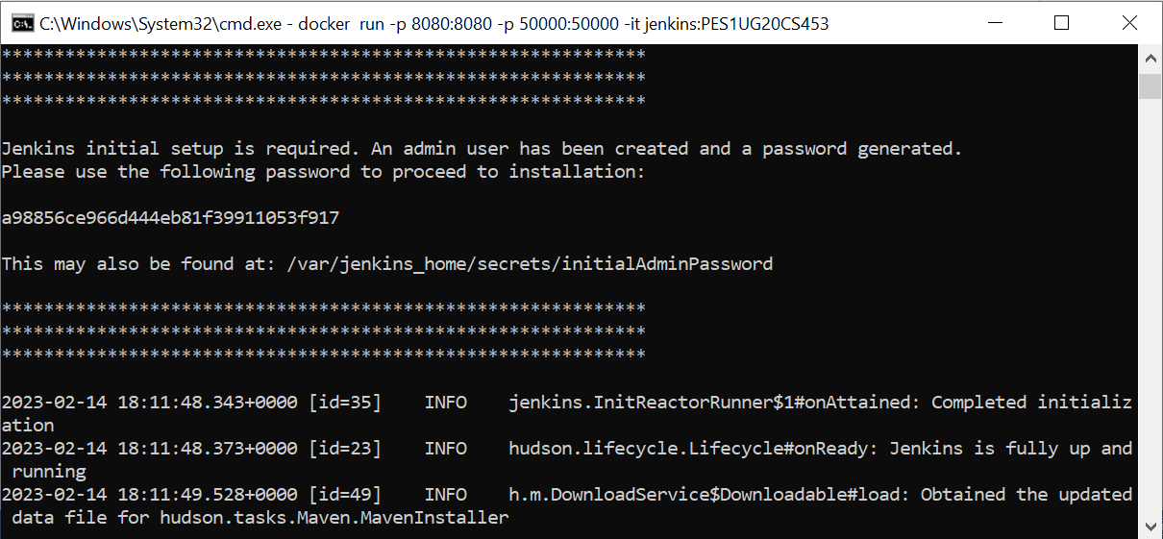

2)